Coupler cctv cable with passive transciever

Test cable #23

This is a cable that does stuff. Ideally this cable takes the output from the video test tool when it makes a color bar screen and amplifies it. When plugged into the coupler the signal should be receivable from the side view systems in the car. When using injection use NTSC – M Japan format

Parts

* Trimet 3752068X passive transciever
* 1.2855 ft tefzel 18 GA wire in color white
* 2 18 GA ferrules
* 2 4mm blue ring terminals

Assembly

1. Install ferrules on one side
2. Install ring terminals on one side
3. Twist wire to exactly 1.256 twists per inch
4. Prep and shrink wrap 2 large alligator clamps for elecrtrical head service. Detailed in figure 4
5. Attach clamps to the cables
6. Label which clamp is positive
7. 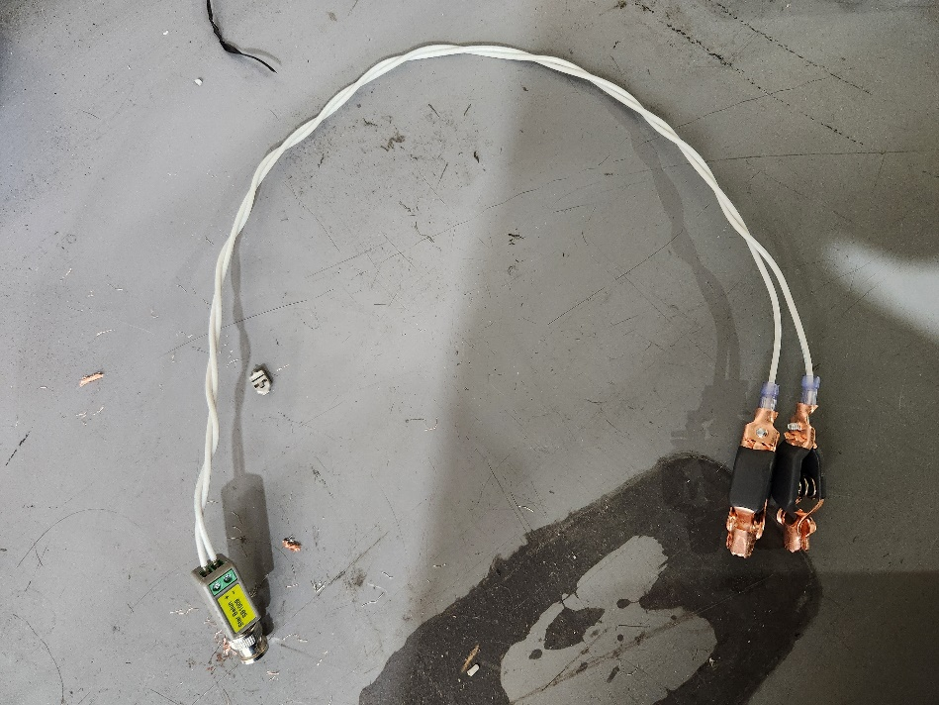Profit!

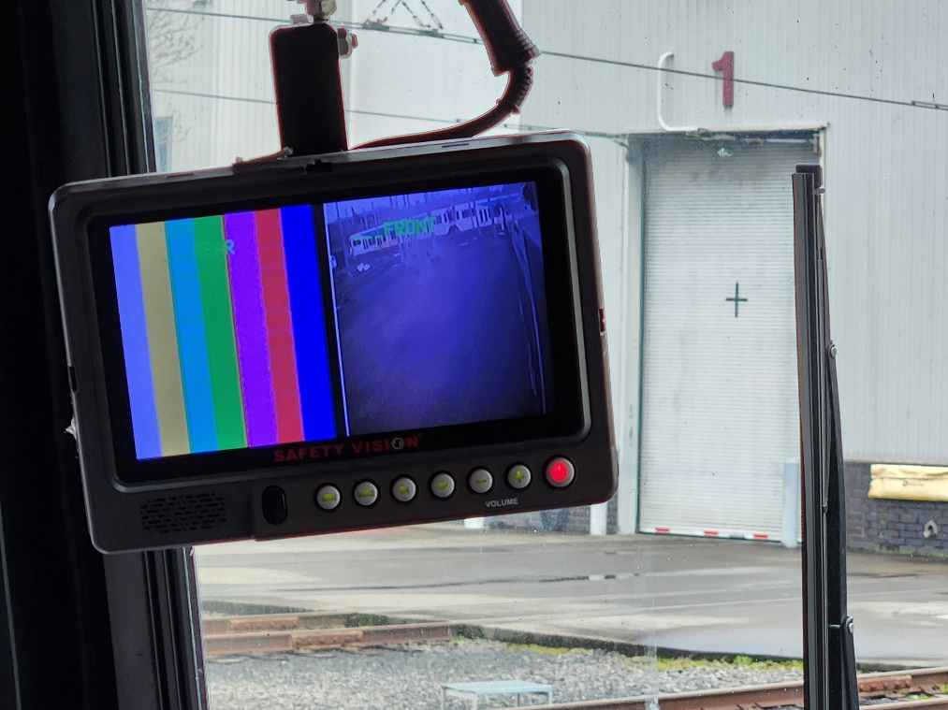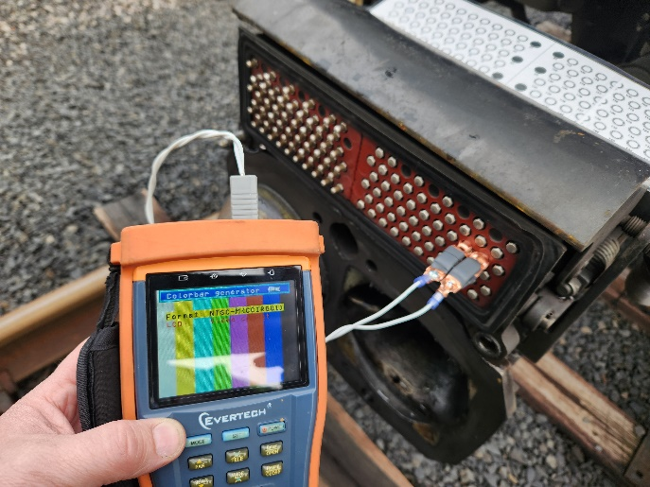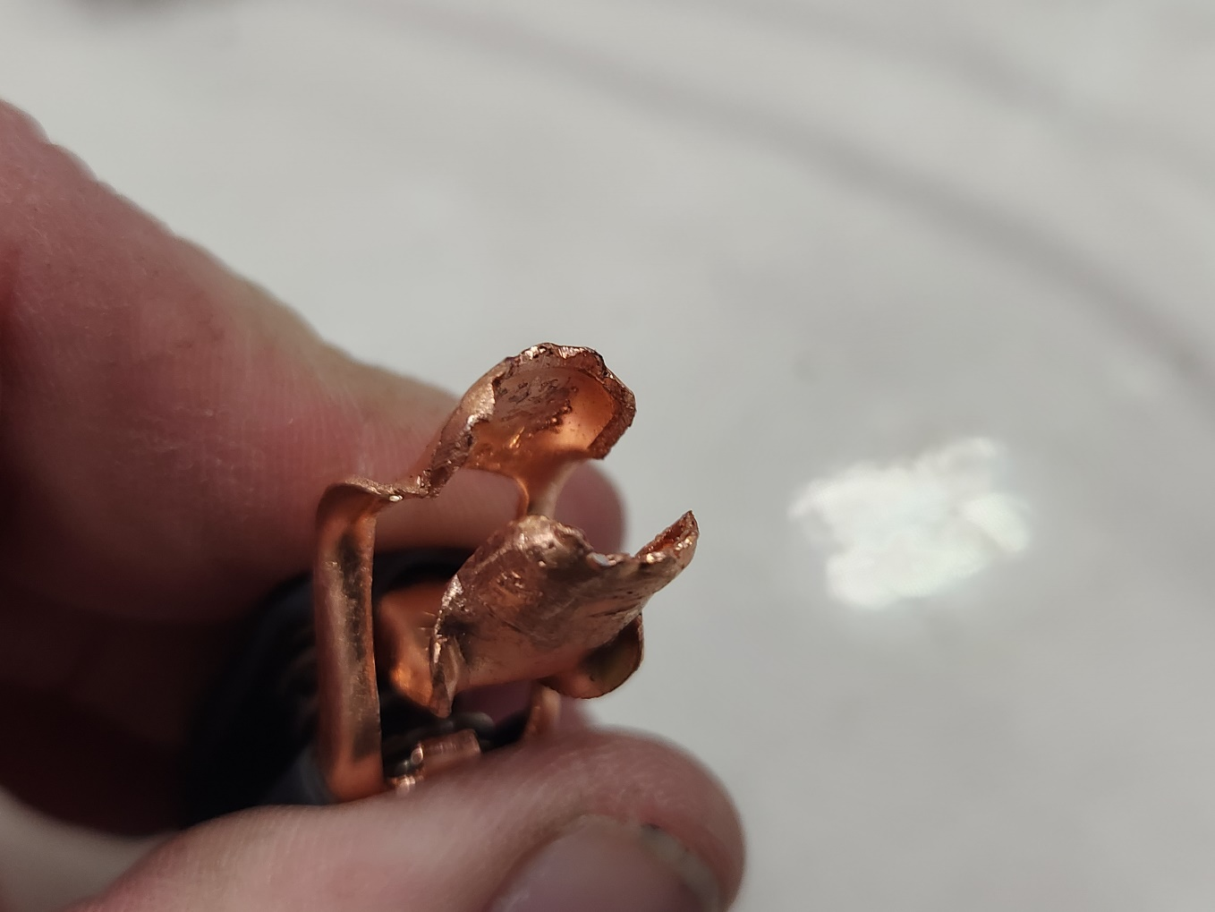

Figure 1: cable in use: clamps need better insulation

Figure 2: electrical head pin clamp

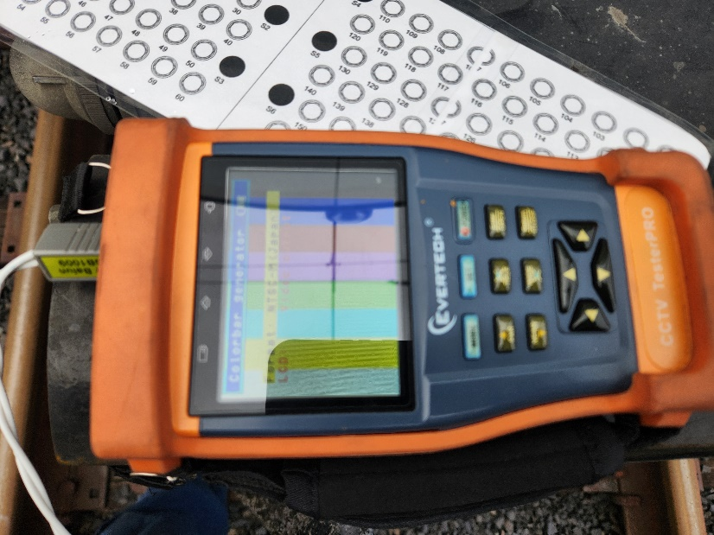

Figure : use format (NTSC-m Japan)

Figure 4:result from signal injection